Physical and Mental Resiliency: An Introduction to Box Breathing
Lindsey Lawrence

What if I told you, breath work is the new “close your eyes and count to ten” solution you can implement at anytime, anywhere?
Stressful, demanding and overloaded schedules can take a toll on everyone’s life. It’s simple to acknowledge the effects stress has on the body mentally, but many don’t know the effects stress can manifest in the body physically. What if there was a way to cope with that stress by doing something so simple such as breathing in and out?

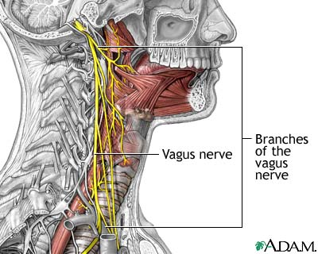
What happens to our bodies when we are stressed?
When we are stressed, our Sympathetic Nervous System (SNS) engages in a “flight or fight” response. Our heart rate increases, our breath becomes shallow, our muscles tense up and our body becomes highly alert and sensitive. Long term stress and overactive SNS can result in further diseases or mental illnesses. Depression, anxiety, and weakened immune systems are all reported illnesses experienced by individuals with high stress.

What can we do to find build resiliency during stressful periods in our lives?
Studies have shown that simple solutions such as meditation and intentional breath work can drastically decrease the effects of stress on the body and increase our resiliency as a whole. When we breathe intentionally, the vagal nerve signals the body’s Parasympathetic nervous system (PSNS) to turn on. Our Heart rate and blood pressure slow down, and muscles relax. Breath allows the diaphragm to massage influential muscles such as the Psoas, a muscle responsible for hip and muscle tightness. Lastly, a big breath builds pressure around the diaphragm signaling comfort and releasing oxytocin.
Psoas Muscles

What is Box Breathing? How do I Box Breath?
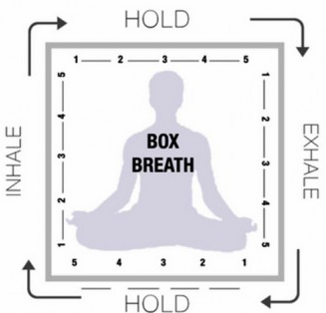
Box Breathing is a technique developed by a Navy Seal as a means of enhancing performance by keeping calm during stressful missions. To start, begin by visualizing a box with equal sides and empty the lungs completely. During the inhale, the individual will breathe through the nose and count to 4 while drawing a line vertical in their mind. Hold the breath in for 4 counts while the line draws horizontal. Exhale for 4 counts as the line draws down, and then count to 4 while the lungs remain empty and the shape of a “box” is completed. You’ll continue with this pattern breath until feelings of stress or emotions have passed.

How do I bring Box Breathing to my everyday life?
Box breathing is a perfect complement for anyone to experiment with meditation mindfulness. The visual of the box and focus on the breath all incorporate basic techniques for meditation/mindfulness. Box breathing can be used at any time and can be a great compliment to improving insomnia, performance and an overall sense of well-being.

How Can I Find Out More About Box Breathing and Meditation?
If you are seeking to further explore these options, as well as meditation or mindfulness, there are plenty of great apps to help support your goals below. You can always reach out to me for any further questions or suggestions through my email at Lindsey.lawrenceb@gmail.com or Instagram @LindsB_Yogi.

Mindfulness Apps Breathing Apps

Additional Resources

Daily Bandha- Combining Modern Science with the Art of Hatha Yoga
https://www.dailybandha.com/

Yoga International- Releasing Tension in the Psoas
https://yogainternational.com/article/view/release-tension-in-the-psoas

NCBI: The Effect of Diaphragmatic Breathing on Attention, Negative Affect and Stress in Healthy Adults
https://www.ncbi.nlm.nih.gov/pmc/articles/PMC5455070/

